Early Detection of Parkinson’s Disease using Acoustic Biomarkers and Machine Learning

Github: https://github.com/sairamchittem/MSc-Data-Science-Individual-Project-Module-7PAM2002-0901-2025.git

Acknowledgement
I would like to say that I want to thank my project supervisor because he supported me, provided me with feedback and guidance as well as academic support in this project. I also recognize the University of Hertfordshire, which availed the academic materials and the learning facilities to carry out this piece of work. I would also like to acknowledge all the contributors of the UCI Parkinson’s Telemonitoring Dataset to provide it publicly and the creators of Python and its data science libraries that allowed performing the analysis and application of the machine learning models applied in this project.

Abstract
This is the project where the question is investigated whether machine learning regression models can help appropriately predict the severity of Parkinson's disease based on acoustic voice biomarkers. The purpose is to compare and formulate Linear Regression and Decision Tree regression models to predict total UPDRS scores. The research employs publicly accessible telemonitoring data of Parkinson's created by acoustic features, demographic and clinical severity measurements. An organised data science process was undertaken with data preprocessing, exploration data analysis, feature scaling and model training under supervision with an eighty-twenty train-test split. R-squared, ROOT MEAN square error and Mean Absolute Error were used to measure model performance. These findings indicate that Linear Regression is easy to use to get a baseline but exhibits little predictive power. The Decision Tree Regressor, in its turn, has a significantly better accuracy and prediction error due to its ability to identify nonlinear relationships in the data. The feature importance analysis also demonstrates the usefulness of main acoustic biomarkers and demographic variables in the prediction of severity. The results indicate that machine learning models, especially tree-based models, also have the potential to assist reliable and non-invasive evaluation of the severity of Parkinson's disease and has application in remote monitoring and clinical decision support systems.

Table of Contents
1. Introduction 7
1.1 Project Overview 7
1.2 Industry and Application Context 7
1.3 Research Question 7
1.4 Aims and Objectives 7
2. Background and Literature Review 8
2.1 Introduction to Literature 8
2.2 Review of Key Studies 8
2.3 Critical Analysis of Literature 8
2.4 Relevance to This Project 9
3. Dataset and Exploratory Data Analysis 10
3.1 Dataset Description 10
3.2 Justification for Dataset Selection 10
3.3 Data Loading and Preprocessing 10
3.4 Exploratory Data Analysis 12
4. Ethical Issues 15
4.1 Ethical Considerations Overview 15
4.2 Data Privacy and Anonymisation 15
4.3 Legal and Regulatory Considerations 15
4.4 Data Usage and Permissions 16
5. Methodology 16
5.1 Methodological Overview 16
5.2 Software and Tools Used 16
5.3 Feature Selection and Preparation 16
5.4 Model Selection 17
5.5 Model Training 17
5.6 Evaluation Metrics 17
5.7 Model Optimisation 17
6. Results 18
6.1 Model Performance Results 18
6.2 Visual Results 19
6.3 Summary of Results 21
7. Analysis and Discussion 21
7.1 Interpretation of Results 21
7.2 Model Comparison 22
7.3 Comparison with Literature 22
7.4 Limitations 22
7.5 Implications and Practical Use 22
7.6 Research Question Evaluation 23
8. Conclusion 23
References 24
Appendices 26

1. Introduction

1.1 Project Overview
The proposed project aims at estimating the severity of Parkinson disease by data driven approaches on the acoustic voice biomarkers (Naeem et al., 2025). The aim of the project is to examine the hypothesis of whether machine learning regression models can effectively predict scores of disease severity based on non-invasive voice measurements. Prediction of the severity of PD is one of the essential challenges, as the disease is slowly developing and an early diagnosis can help provide the necessary clinical intervention.
Data science and machine learning can offer methods to analyse sophisticated biomedical data and discover the trends that would be hard to find with the old statistical methods (Rehman et al., 2022). In this project, regression techniques are used under the supervision of the regression tool to model the dependency relationship between the acoustic characteristics obtained with speech and clinical severity scores.

1.2 Industry and Application Context
Parkinson’s disease is also assessed in clinical practice through structured rating scales which include the Unified Parkinson Disease Rating Scale. Such assessments are normally done in face-to-face visits, and they are based on specialist observation. The method may be time consuming, subjective, and inappropriate in terms of constant monitoring.
The traditional assessment method also contributes to an inability to measure minute variations that take place between clinical visits. The other method is the use of acoustical biomarkers since speech impairment is an early and frequent effect of Parkinson’s disease (Rusz et al., 2021). Machine learning is able to scale the analysis of these biomarkers, which allows remote, cost effective and non-invasive measurements of severity.

1.3 Research Question
“Can machine learning regression models accurately predict Parkinson’s disease severity using acoustic biomarkers?”

1.4 Aims and Objectives
Aim
The objective of this project is to build and test machine learning models to predict severity of Parkinson disease using voice-based acoustic features.
objectives
- To work out and train the Linear Regression and Decision Tree regression models to predict the severity of Parkinson.
- To assess the performance of the models in terms of R-squared, RMSE, and MAE.
- To define which acoustic biomarkers should be the most influential on predictive performance and model cognizability.

2. Background and Literature Review

2.1 Introduction to Literature
The nature of Parkinson's disease is progressive and its effects on motor control, speech as well as quality of life have made it an area of wide research in the field of full-time nursing science (Cronin et al., 2024). The recent studies on this topic have paid more attention to early diagnosis and the level of severity because with precise monitoring, it will be possible to conduct early intervention and provide better patient care. Conventional clinical tests have the strengths of being insightful but tend to be of low quality due to subjectivity and low frequency.
Latest developments in data science have also allowed applications of machine learning to interpret biomedical data in a better way. The focus on the acoustic biomarkers resonant in the speech signals is due to the fact that speech impairment is a frequent and early symptom of Parkinson's disease. Such biomarkers detect minute changes in vocal stability, frequency and noise that are associated with the progression of the disease. The machine learning models are suitable in this task because they can be used to detect complex patterns in high-dimensional acoustic data.

2.2 Review of Key Studies
Some research has been done on voice based features as a means of analysis of Parkinson disease. One main study reported the ability to predict disease severity in the form of acoustic biomarkers based on a sustained phonation recording. The data were voice samples (recorded as time went by) of the patients diagnosed with Parkinson disease. Regression models like the linear regression and the support vector regression were used. The findings showed acoustic features had moderate predictive power of clinical severity scores, which indicates the possibilities of non-invasive monitoring (Ahmadli et al., 2024).
The other researchers were interested in machine learning classification and regression analysis to differentiate patients of Parkinsonism and healthy control with another aim of estimating their severity. Various speech activities and acquired acoustic features were contained in the dataset.

An additional article was a longitudinal voice study that followed the progression of disease. Decision tree-based methods and neural networks were taken and used to model changes in severity as they progressed through time, by the authors. They found that tree-based models were easier to interpret with comprehensible rules of decision making and worked as well as more complex models. Nevertheless, the weaknesses of the study included overfitting and lack of sample variance.
The other Correlation that was considered is the analysis of various machine learning models based on acoustic data as well as demographic data (Zhou et al., 2023). The comparative study presented between a linear model and nonlinear model revealed that whereas a linear regression was easy to interpret, nonlinear models always produced lower error of predictions. The authors have focused on the need to scale the features appropriately and evaluate them with various measures.

2.3 Critical Analysis of Literature
The analyzed literature is indicative of the fact that acoustic biomarkers may serve as a source of accurate information to examine Parkinson disease. One of the strongest aspects of this literature is that the literature is consistent in demonstrating that speech features are associated with disease severity. This justifies the possibilities of voice-based monitoring systems that are non-invasive (Hassan and Ahmed, 2023).
Nevertheless, there are several drawbacks that are apparent. A large proportion of studies are based on quite small datasets hence limiting generalisability. Other methods are heavy on complicated models with limited explanation of how they are understood, which may cause clinics to mistrust the approaches. Also, other studies indicate performance in terms of one evaluation measure, which makes it hard to comprehensively evaluate model reliability.
The other weakness is the absence of a direct comparison between the simple forms of baseline and the more sophisticated approaches. In various instances, linear models are either avoided or not strictly tested. This leaves a void in the knowledge of whether greater model complexity is justifiable in every case. Moreover, other studies fail to effectively connect their results to clinical practice.
Such gaps indicate the necessity of research that compares interpretable baseline models with nonlinear methods with consistent datasets and measures of evaluation. Also, more explicit consideration of the ways in which such models may be useful in the case of disease monitoring in the real world is needed.

2.4 Relevance to This Project
The methodology used in this project is directly related to the reviewed literature. The rationale behind the choice of voice-based features relates to the support of the use of acoustic biomarkers as predictors of the severity of Parkinson’s disease in the past. It is the comparison between linear and nonlinear models in previous research which inspires the choice of Linear Regression as a control and use of Decision Tree regression as a more adaptable model.
It is also indicated in the literature that it is necessary to use several evaluation metrics. Consequently, RMSE, and MAE are utilized in this project to give an in-depth evaluation of the performance of the model (Varshini et al., 2021). The analysis of feature importance is provided to solve the interpretability issue that has been mentioned in previous analyses.
This project fills in unidentified gaps in the literature by concentrating on a simple comparison of two regression models whose preprocessing and evaluation have been done in a consistent manner. It adds the interpretable and well-organized analysis that streamlines the machine learning performance with a practical application in the scenario of predicting the severity of Parkinson changes in the area of machine learning.

3. Dataset and Exploratory Data Analysis

3.1 Dataset Description
The dataset sought is the Parkinson Telemonitoring dataset that is found within an open research repository. Medical researchers gathered the data in a controlled healthcare environment when they were clinical monitoring patients with Parkinson. It was collected to examine the progress of disease, and it consists of demographic data, the severity of clinical cases, and the acoustic voice biomarkers obtained on speech samples.

3.2 Justification for Dataset Selection
This data is appropriate since it directly correlates acoustic biomarkers and clinically validated scores of severities of the disease in patients with Parkinson. It both accommodates regression based modelling and objective severity prediction through noninvasive data. The multi-voice feature and longitudinal measurements can easily make it acceptable to the study and evaluation of disease progression as well as the use of machine learning in projecting severity levels.

3.3 Data Loading and Preprocessing
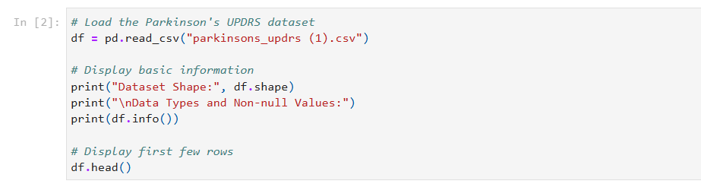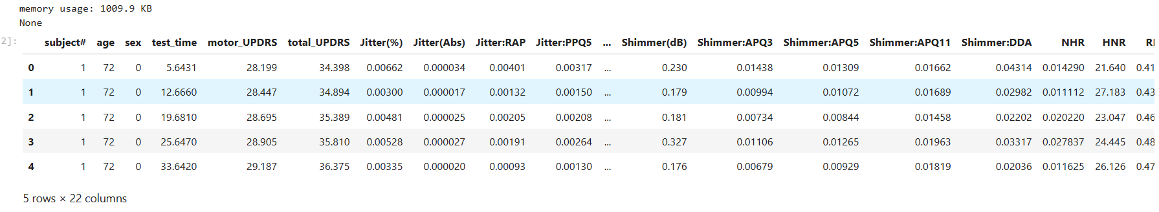
Figure 1: Load Dataset
This number displays the successful loading of the Parkinson dataset of UPDRS entered the analysis space. It validates the data format, such as the number of records and features. The preview of the initial few rows gives a preliminary idea about the names of features, type of data and values of samples. This is to make sure that the data set has been properly imported after which a preprocessing or analysis is done.

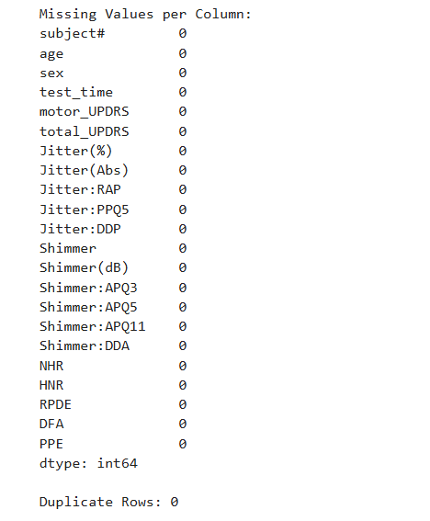
Figure 2: Missing values
This figure shows the finding of missing value and duplicate check. There are no missing values in all the variables, and no row is found to be replicated. This means that there is high quality of data and imputation or removing records are not necessary. This step can be made complete to enhance the consistency of further exploration and model training.
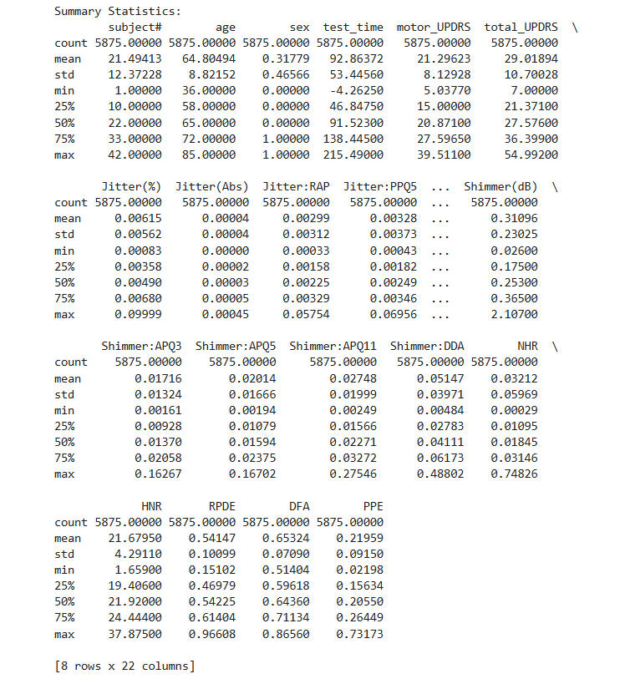
Figure 3: Summary Statistics
This figure takes a summary of all the variables of the data set in terms of mean, standard deviation, minimum and maximum values. It brings to the focus of attention the variety and allocation of demographic, clinical, and acoustic characteristics. The statistics indicate the existence of variation among the biomarkers and prove that the model needs to be trained on feature scaling to maximize the contributions.

3.4 Exploratory Data Analysis

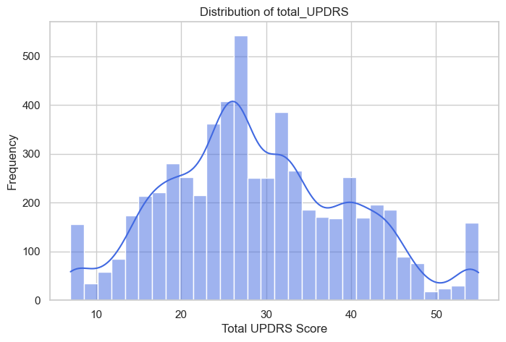
Figure 4: Distribution of total UPDRS
This number portrays that the overall UPDRS severity scores are evenly distributed. There is a wide distribution of values in the histogram signifying that mild to severe cases of Parkinsonism are represented. The near normal shape implies that it will be suitable with regression modelling. This distribution will affirm the fact that the data set represents levels of disease severity needed to make predictions.
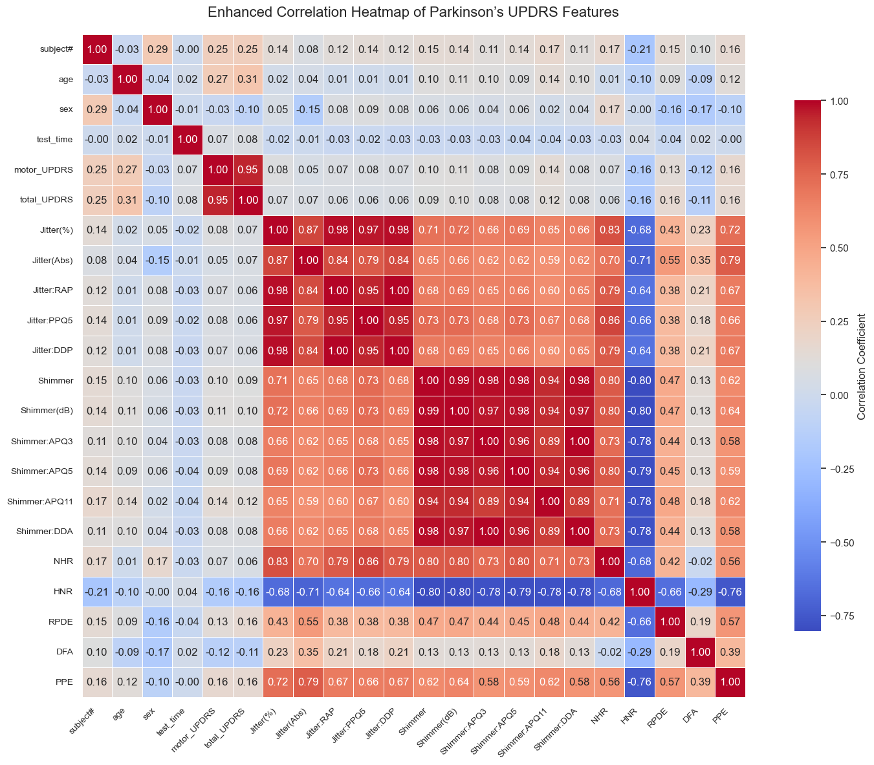
Figure 5: Enhanced Correlation Heatmap of Parkinson's UPDRS Features
This figure is visualisation of correlations between all the features and target variable. Close positive relationships are found between total UPDRS and motor UPDRS whereas moderate relationships are observed with several acoustic biomarkers. Voice features have great interred correlation, which means that there are similar vocal patterns. This analysis is relevant to features and is useful in feature selection and interpretation of the models.
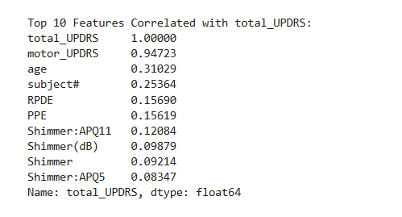
Figure 6: Top 10 Features Correlated with total UPDRS
This number is a list of the top ten features that have the highest relationship with total UPDRS. The highest correlation is observed with Motor UPDRS, then there is age and the chosen acoustic biomarkers that include RPDE and PPE. These findings also show some clinically meaningful predictors that warrant inclusion in modelling.

4. Ethical Issues

4.1 Ethical Considerations Overview
Special attention to ethical aspects was paid to the decision to conduct this project to minimize the risks of irresponsible use of data and the incorrect implementation of machine learning methods (Rizinski et al., 2022). The research is based on secondary research data that was already obtained in the past to carry out research, implying that no direct data were collected among participants. Irrespective of this, relevant ethical points that associate privacy, consent, and usage of data were reviewed in order to ensure that the analysis is within accepted academic and professional standards.

4.2 Data Privacy and Anonymisation
The personal information that can be recognized in the data set of this project is not identified directly, in terms of names, addresses, or contacts. Rather, the participants of the research are presented by an anonymous identifier. Demographic data only contain general facts like the age and sex, which is not enough to determine individuals per se. The anonymisation of the dataset is done by eliminating personal identifiers followed by the release of the dataset in open access. Voice data underwent voice recordings to numbers, which implied that voice files were not present. This will go a long way in lowering the chances of re-identification. Consequently, the privacy of participants is upheld and, at the same time, analysis of the pattern of severity of the disease can be meaningfully done.

4.3 Legal and Regulatory Considerations
The dataset is subject to data protection laws such as GDPR since it derived its origin out of human subjects (Crutzen et al., 2019). Nevertheless, the data is anonymised and publicly available to allow use in research and this substantially lowers the risk of regulation. The project involves using the secondary anonymised data, and no direct interaction with the participants, so formal institutional approval of the ethics did not take place. No personal information was gathered, stored and processed in this project. All the analysis was done locally in a secure computing environment. The project works have aggregation and analytical nature of outputs and no participant can be identified using results or visualisations.

4.4 Data Usage and Permissions
This dataset is shared in a research public repository where the use of the data to research is granted. Its availability implies that the participants gave the necessary consent during the data collection. The source of the information used is a good research environment and has been extensively employed in peer reviewed research, which gives credit to its ethical gathering and sharing. It was not necessary to buy the dataset or get other permissions. The data set was only applied in the context of research and education.

5. Methodology

5.1 Methodological Overview
This project has been developed based on a consistent data science workflow, to forecast the severity of Parkinson’s disease with the help of acoustic voice biomarkers. Data loading and quality checking is the starting step of the methodology, then there is the exploratory data analysis where we get an appreciation of the feature distributions and relationship. Regression models of machine learning are then trained under the supervision to predict total scores on UPDRS. Multiple regression measures are used to assess model performance, and the results are analysed to judge their accuracy, understandability, and usefulness.

5.2 Software and Tools Used
The Python programming language was adopted to implement the project since it has a good capacity for data analysis and machine learning (Nagpal and Gabrani, 2019). Pandas and numpy were used as core libraries to manipulate data, matplotlib used to visualise the data and scikit-learn used to develop, pre-process and evaluate models. It can be analysed in an environment based on the Jupyter Notebook, which provided the opportunity to develop it interactively, document it, and reproduce results.

5.3 Feature Selection and Preparation
Both domain relevance and explore analysis informed the feature selection (Spooner et al., 2023). Demographic features and acoustic biomarkers were not eliminated because they reflect clinically significant data regarding the development of Parkinson disease. The identifier variables were eliminated to prevent noise to the models. The variable to be targeted was total UPDRS, an overall severity of the disease.

5.4 Model Selection
In this study, two regression models have been chosen in a bid to facilitate comparative study. The reason why Linear Regression was selected as a baseline model is that it is easy to interpret, simple and is common in biomedical studies. It presupposes the linearity between the input features, and the target variable, and its use will be appropriate in determining the baseline predictive performance.
Decision Tree Regressor was chosen as an alternative nonlinear model with the ability to model the complex interactions between features. Decision Trees operate on the principle of splitting the data based on the values of features that are recursive and they help in reducing the mistakes of prediction. This structure enables the model to transpire nonlinear relationships and has interpretability as the model has measures of feature importance. Simplicity and flexibility can be assessed with the help of the two combined types of models.

5.5 Model Training
In this study, two regression models have been chosen in a bid to facilitate comparative study. The reason why Linear Regression was selected as a baseline model is that it is easy to interpret, simple and is common in biomedical studies (Kan et al.,20109). It presupposes the linearity between the input features, and the target variable, and its use will be appropriate in determining the baseline predictive performance.
Decision Tree Regressor was chosen as an alternative nonlinear model with the ability to model the complex interactions between features. Decision Trees operate on the principle of splitting the data based on the values of features that are recursive and they help in reducing the mistakes of prediction.

5.6 Evaluation Metrics
Three regressions were used to ascertain model performance. R square is a measure of the percentage of variance in the target variable, which can be used to understand the ability to explain. Root Mean Squared error measures the size of the average prediction error and higher errors are punished more harshly. Mean Absolute Error is used as a gauge to the average difference of predicted and actual values based on the error.
The reasons why these metrics were selected include the fact that they combine measures of accuracy, error value, and model reliability. Measuring performance with various metrics will help to have the balance of assessment and will help to make a meaningful comparison of models.

5.7 Model Optimisation
Predictive performance was enhanced through a model optimization to regulate complexity. The maximum tree depth and minimum number of samples per leaf are parameters that can be adjusted to speed up decision tree regression to limit the opportunity to overfit. These limitations enhanced the area of generalisation because it did not allow the model to learn too specific patterns.
Linear Regression was not much tuned because there are few hyperparameters. The main optimisation steps to this model were feature scaling and feature selection care. Generally, optimisation enhanced stability and made performance gains based on true learning as opposed to noise.

6. Results

6.1 Model Performance Results
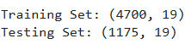
Figure 8: Split the Dataset
The dataset was subdivided to test the performance of the model objectively to form two sets. The training set consists of 4,700 samples; 19 features and was used to train models of machine learning based on learning relationships between acoustic biomarkers and the severity of the disease of Parkinson. The test group consists of 1,175 samples, the same 19 features and was not viewed during training. Such segregation makes the evaluation of the model responsive to generalisation of new data, as opposed to location of the pattern in training. A 80-20 ratio was chosen because it gives enough data to be used in training and leaves a representative sample to be used in good performance evaluation.
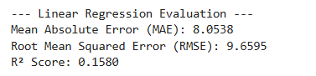
Figure 9: Linear Regression Evaluation
Mean Absolute Error is an indicator of the mean absolute error in the predicted and actual scores of SE of Parkinson’s disease. This is due to its ease of interpretation of prediction error expressed in the same units as the UPDRS scale. In the given project, an MAE of 8.05 shows that the models on the Linear regression on the severity scores have a higher prediction error of more than an eight point on average, which may be limited accuracy.
Root Mean Squared Error is a metric of the square root of mean squared errors of prediction. It punishes bigger errors more severely than MAE and therefore is useful in detecting models with some large errors. The value of RMSE at 9.66 implies that there is a high variability of the prediction errors meaning that the model has a problem fitting the data in a consistent manner.
R2 score is used to give the percentage of variation in the severity of the Parkinson disease that the model will explain.
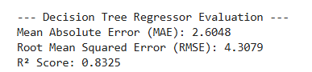
Figure 10: Decision Tree Regressor Evaluation
Mean Absolute Error indicates the mean difference between the anticipated and the realized severity scores of Parkinson disease in terms of UPDRS. This is suitable in this project since it gives a quantifiable and interpretable indicator of how well a prediction is effective. As indicated by the MAE of 2.60, The Decision Tree model predicts severity with a small average error i.e. it has high precision as compared to other simpler models.
Root Mean Squared Error is a measure of the square root of the average of square prediction errors, which puts higher weight upon the high deviations. The metric will help in determining the stability of the model and its susceptibility to enormous errors in prediction. The minimum RMSE of 4.31 illustrates that the Decision Tree makes fewer severe errors, which proves stable samples have the same performance.
R 2 score is used to determine the ratio of the variance of disease severity, which is attributed to the model, thus it is appropriate to use it in regression analysis. The R2 of 0.8325 demonstrates that the Decision tree captures more than 83 percent of the variability in total scores of the UPDRS which represents an excellent fit in the model and ability of the model to fit nonlinear relationships among the acoustic biomarkers.

6.2 Visual Results
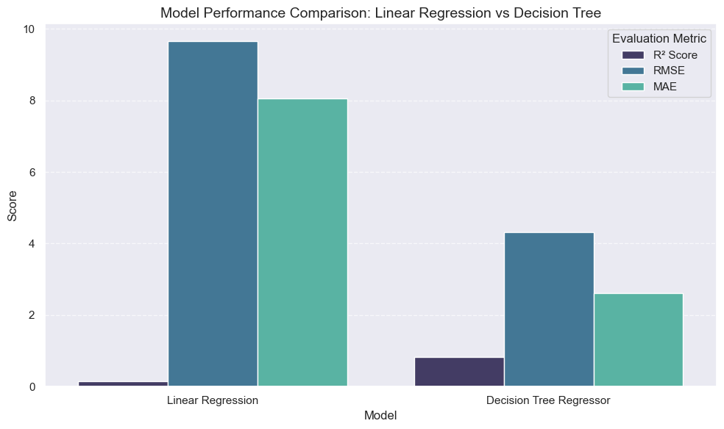
Figure 11: Model Performance Comparison: Linear Regression vs Decision Tree
Linear Regression attains a very low R2 based on which implies that it captures only a minor percentage of variability in overall UPD SRS scores. Its large and varied post error values of RMSE and MAE indicate that it is underfitted and cannot describe the non-linear associations between acoustic biomarkers.
Instead, the Decision Tree Regressor displays a significant value of R2 with considerably less values of RMSE and MAE. It means that it explains most of the changes of illness severity and results in more correct and consistent forecasts. These findings suggest that nonlinear models are more appropriate to be applied to the case of whether to monitor the severity of the physical condition of the Parkinson patient.

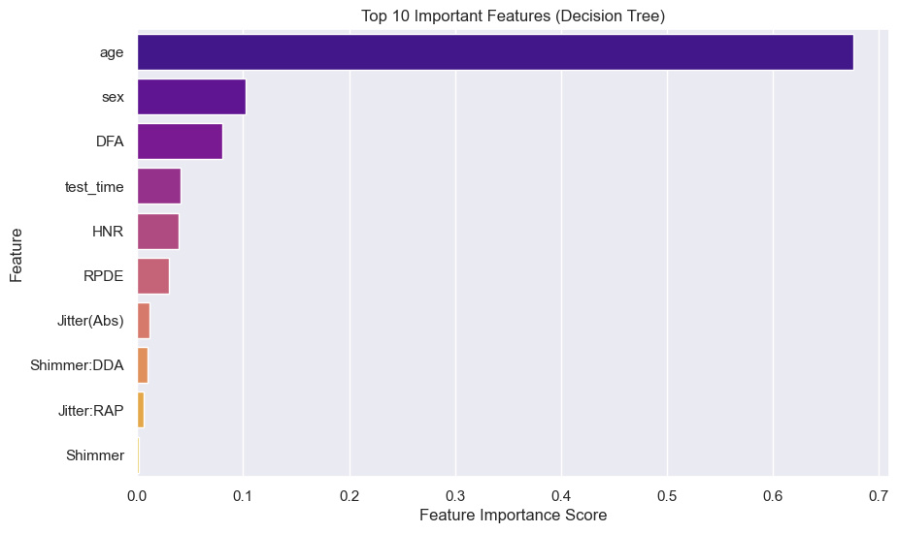
Figure 12: Top 10 Important Features (Decision Tree)
The feature importance analysis provides information on the importance that the Decision Tree Regressor places on variables contributing to the predictors of the severity of Parkinson disease. The prevalent characteristic that comes out is age, which means that the development of the disease has a strong relationship to the age of the patient. DFA, HNR, RPDE, and jitter-based features are considered the acoustic measures that reflect the significant importance of changing the vocal stability and complexity of signals with the progression of the disease.
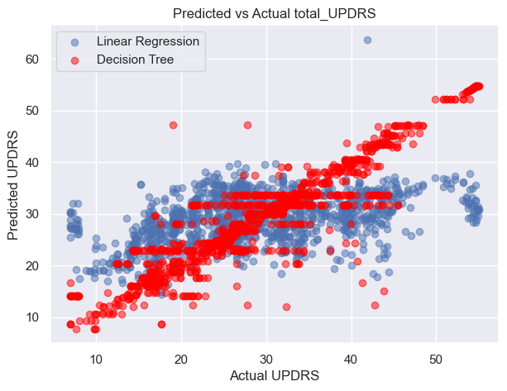
Figure 13: Predicted vs Actual total UPDRS
It can be seen through the predicted and the actual plot that there is a difference in performance of the two models. Decision Tree predictions immediately follow the diagonal pattern meaning that there is very close agreement between the obtained predicted and real value of UPDRS at the different levels of severity. Conversely, Linear Regression projections are more spread and are concentrated to the mean, which is an example of underfitting.

6.3 Summary of Results
The findings justify the results that machine learning regression models can estimate the severity of Parkinson’s disease with the help of acoustic biomarkers, and the Decision Tree Regressor does it significantly better than Linear Regression. The Decision Tree was found to have a high predictive power and low predictive error, which proved that it can be used to model the nonlinear vocal patterns. These results advocate voice-based data as a non-invasive method of monitoring diseases. The project answers the research question by demonstrating that accurate severity prediction is possible and indicates that it would be useful in real world scenarios in clinical decision support and remote patient monitoring systems.

7. Analysis and Discussion

7.1 Interpretation of Results
The findings point to the fact that acoustic biomarkers (voice recordings) may be successfully used to predict the severity of Parkinson Diseases. The Decision Tree Regressor was also highly predictive as it recorded high explanatory power and low error measures. This implies that meaningful information based on the progression of a disease is extracted in the vocal features. This in practice implies that a quantitative severity estimate can be obtained by measuring fine variations in speech patterns. Linear Regression, as a baseline, did not perform well in the complex patterns, leading to the increase of prediction errors. In general, the results reveal that the severity of the disease is affected by the nonlinear interaction of demographic and acoustic factors instead of the linear trends.

7.2 Model Comparison
The Decision Tree Regressor was obviously performing better than Linear Regression in all evaluation measures. It recorded a much higher score in R2 and a significantly lower score in RMSE and MAE. This difference in performance is attributable to the genres of the models. Linear Regression presupposes that there is a linear relationship between features and the target variable and therefore it will not be capable of modeling any complex biological process. The Decision Tree on the other hand can model nonlinear relationships as well as feature interactions (Li et al., 2023). The development of the Parkinson Diseases is nonlinear in nature and the interaction between acoustic biomarkers is also complex. The Decision Tree model could adjust to these trends leading to more precise and settled predictions.

7.3 Comparison with Literature
The results of the present study align with the already available research that identifies effective machine learning models in predicting the severity of Parkinson's disease through speech samples. Past research has indicated that tree based, and nonlinear models are known to do better than linear methodologies in the analysis of acoustic biomarkers. As seen in this case, literature proposes such factors as jitter, shimmer, signal complexity measures, and demographic factors as the contributive factors to the severity estimation (Chhillar, 2025). The high success of decision trees agrees with the benefits of interpretable machine learning models reported in the biomedical world.

7.4 Limitations
Regardless of the encouraging outcomes, several limitations should be mentioned. The sample of this project consists of only 42 subjects, and it is a constraint on demographic diversity and generalisability. Even though there are quite a lot of recordings, the repeated measures of the same individuals can be biased. Also, the two regression models were analyzed, which limits the model comparison. Basic tuning was used only in hyperparameter optimization, and other sophisticated optimization methods can be developed to enhance even better performance. Lastly, the data is a set of voice records actively monitored, which is possibly not like actual speech taken in the real world.

7.5 Implications and Practical Use
The findings indicate great possibilities of practical use. The decision tree model gives precise and understandable forecasts and can be applied to clinical decision support systems. A non-invasive technique, acoustic based severity prediction, as an option to regular face-to-face evaluations, is less expensive. This solution might aid in keeping a distant watch on the patients, preventing the disease progression in early stages, and tracking the effectiveness of the treatment process. Other combinations such as neurological and speech related disorders can be treated using the same methodologies as those in the case of Parkinson disease (Saluja et al., 2023). But further clinical use would need to be validated upon larger and more heterogeneous datasets, as well as incorporated in secure healthcare systems.

7.6 Research Question Evaluation
The research question was the ability of machine learning regression models to predict the level of severity of Parkinson disease using acoustic biomarkers. This question is obviously answered by the results. The Decision Tree Regressor showed a high predictive accuracy, and various severity was largely explained with the Decision Tree Regressor, an aspect that proves acoustic features to be effective predictors. Linear Regression did not perform very well; however, it was a good benchmark to use.

8. Conclusion
The research question in this project was whether machine learning regression models can transparently predict the severity of Parkinson disease based on the acoustic biomarkers of voice recording. The most important findings are that the Decision Tree Regressor performed significantly better than the Linear Regression on all the assessment measures. It had a significant high R2 and a much lower value of MAE and RMSE, which illustrates its potential to explain nonlinear association, which is evident in the variables of the voice and demographics. Linear Regression was also a useful baseline but underfitted and had poor explanatory ability.
Our conclusion of this paper is that acoustic biomarkers have significant content on the development of Parkinson disease and can be effectively used to forecast the severity when an appropriate machine learning model is used with them. The Decision Tree model was not only accurate but also interpretable thus being especially found to be appropriate in relation to healthcare-related applications where transparency is a factor.
The suggested future directions are quite simple: the validation of the types of models on bigger and more diversified datasets, tests with more complicated models like ensemble and deep learning algorithms, and implementation of the predictive system in the clinical decision support application to be used in the real time.

References
Naeem, I., Ditta, A., Mazhar, T., Anwar, M., Saeed, M.M. and Hamam, H., 2025. Voice biomarkers as prognostic indicators for Parkinson’s disease using machine learning techniques. Scientific Reports, 15(1), p.12129. Available at: https://www.nature.com/articles/s41598-025-96950-3.pdf
Rehman, A., Naz, S. and Razzak, I., 2022. Leveraging big data analytics in healthcare enhancement: trends, challenges and opportunities. Multimedia Systems, 28(4), pp.1339-1371. Available at: https://arxiv.org/pdf/2004.09010
Rusz, J., Hlavnička, J., Novotný, M., Tykalová, T., Pelletier, A., Montplaisir, J., Gagnon, J.F., Dušek, P., Galbiati, A., Marelli, S. and Timm, P.C., 2021. Speech biomarkers in rapid eye movement sleep behavior disorder and Parkinson disease. Annals of neurology, 90(1), pp.62-75. https://onlinelibrary.wiley.com/doi/pdf/10.1002/ana.26085
Cronin, P., Collins, L.M. and Sullivan, A.M., 2024. Impacts of gait freeze on quality of life in Parkinson’s disease, from the perspectives of patients and their carers. Irish Journal of Medical Science (1971-), 193(4), pp.2041-2050. Available at: https://link.springer.com/content/pdf/10.1007/s11845-024-03673-x.pdf
Ahmadli, N., Sarsil, M.A., Mizrak, B., Karauzum, K., Shaker, A., Tulumen, E., Mirzamidinov, D., Ural, D. and Ergen, O., 2024. Voice-driven mortality prediction in hospitalized heart failure patients: A machine learning approach enhanced with diagnostic biomarkers. arXiv preprint arXiv:2402.13812.Available at: https://arxiv.org/pdf/2402.13812
Zhou, Z., Qiu, C. and Zhang, Y., 2023. A comparative analysis of linear regression, neural networks and random forest regression for predicting air ozone employing soft sensor models. Scientific Reports, 13(1), p.22420. https://www.nature.com/articles/s41598-023-49899-0.pdf
Hassan, A. and Ahmed, A., 2023. Predicting Parkinson's Disease Progression: A Non-Invasive Method Leveraging Voice Inputs. Computer Science, 8(2), pp.66-82. Available at: https://dergipark.org.tr/en/download/article-file/3364213
Varshini, A.P., Kumari, K.A., Janani, D. and Soundariya, S., 2021, February. Comparative analysis of Machine learning and Deep learning algorithms for Software Effort Estimation. In Journal of Physics: Conference Series (Vol. 1767, No. 1, p. 012019). IOP Publishing. Available at:https://iopscience.iop.org/article/10.1088/1742-6596/1767/1/012019/pdf
Rizinski, M., Peshov, H., Mishev, K., Chitkushev, L.T., Vodenska, I. and Trajanov, D., 2022. Ethically responsible machine learning in fintech. IEEE Access, 10, pp.97531-97554.Available at: https://ieeexplore.ieee.org/stamp/stamp.jsp?arnumber=9869843
Crutzen, R., Ygram Peters, G.J. and Mondschein, C., 2019. Why and how we should care about the General Data Protection Regulation. Psychology & health, 34(11), pp.1347-1357. Available at:https://www.tandfonline.com/doi/pdf/10.1080/08870446.2019.1606222
Nagpal, A. and Gabrani, G., 2019, February. Python for data analytics, scientific and technical applications. In 2019 Amity international conference on artificial intelligence (AICAI) (pp. 140-145). IEEE.Available at: https://www.researchgate.net/profile/Abhinav-Nagpal-2/publication/332760463_Python_for_Data_Analytics_Scientific_and_Technical_Applications/links/66af51928f7e1236bc35c3fd/Python-for-Data-Analytics-Scientific-and-Technical-Applications.pdf
Spooner, A., Mohammadi, G., Sachdev, P.S., Brodaty, H., Sowmya, A. and Sydney Memory and Ageing Study and the Alzheimer’s Disease Neuroimaging Initiative, 2023. Ensemble feature selection with data-driven thresholding for Alzheimer's disease biomarker discovery. BMC bioinformatics, 24(1), p.9. Available at:https://link.springer.com/content/pdf/10.1186/s12859-022-05132-9.pdf
Kan, H.J., Kharrazi, H., Chang, H.Y., Bodycombe, D., Lemke, K. and Weiner, J.P., 2019. Exploring the use of machine learning for risk adjustment: A comparison of standard and penalized linear regression models in predicting health care costs in older adults. PloS one, 14(3), p.e0213258.
Available at: https://journals.plos.org/plosone/article/file?id=10.1371/journal.pone.0213258&type=printable
Li, C., Zhao, J. and Hou, W., 2023. Nonlinear effects of landscape patterns on ecosystem services at multiple scales based on gradient boosting decision tree models. Remote Sensing, 15(7), p.1919. Available at:https://www.mdpi.com/2072-4292/15/7/1919
Chhillar, R.S., 2025. Machine Learning Analysis of the Telemonitoring Voice Dataset for Enhanced Parkinson's Disease Severity Prediction. Available at: https://www.researchsquare.com/article/rs-6186623/latest
Saluja, A., Goyal, V. and Dhamija, R.K., 2023. Multi-modal rehabilitation therapy in Parkinson's disease and related disorders. Annals of Indian Academy of Neurology, 26(Suppl 1), pp.S15-S25. Available at: https://journals.lww.com/annalsofian/fulltext/2023/26001/multi_modal_rehabilitation_therapy_in_parkinson_s.3.aspx

Appendices

# # Data Loading and Preproceesing

# Basic libraries
import pandas as pd
import numpy as np
import warnings
warnings.filterwarnings('ignore')

# Visualization (optional for checks)
import matplotlib.pyplot as plt
import seaborn as sns

# Machine learning preprocessing tools
from sklearn.preprocessing import StandardScaler
from sklearn.model_selection import train_test_split

# Load the Parkinson's UPDRS dataset
df = pd.read_csv("parkinsons_updrs (1).csv")

# Display basic information
print("Dataset Shape:", df.shape)
print("\nData Types and Non-null Values:")
print(df.info())

# Display first few rows
print (df.head())

# Check for missing values
print("\nMissing Values per Column:")
print(df.isnull().sum())

# Check for duplicate rows
duplicates = df.duplicated().sum()
print("\nDuplicate Rows:", duplicates)

# Remove duplicates if any
if duplicates > 0:
df = df.drop_duplicates()

# Ensure sex is integer type
df['sex'] = df['sex'].astype(int)

# Drop irrelevant identifiers
X = df.drop(columns=['subject#', 'motor_UPDRS', 'total_UPDRS'])
y = df['total_UPDRS']

print("Feature Set Shape:", X.shape)
print("Target Shape:", y.shape)

# # EDA

# ---------------------------------------------
# EDA for Parkinson’s UPDRS Dataset
# ---------------------------------------------

# Import required libraries
import pandas as pd
import numpy as np
import matplotlib.pyplot as plt
import seaborn as sns

# Set display and style
pd.set_option('display.float_format', lambda x: '%.5f' % x)
sns.set(style="whitegrid", context="notebook")

# ---------------------------------------------
# Step 1: Load the Dataset
# ---------------------------------------------
df = pd.read_csv("parkinsons_updrs (1).csv")

print("Dataset Loaded Successfully.")
print("Shape of Dataset:", df.shape)
print("\nFirst Five Rows:")
print(df.head())

# ---------------------------------------------
# Step 2: Summary Statistics
# ---------------------------------------------
print("\nSummary Statistics:")
print(df.describe())

# ---------------------------------------------
# Step 3: Distribution of Target Variable
# ---------------------------------------------
plt.figure(figsize=(8, 5))
sns.histplot(df['total_UPDRS'], bins=30, kde=True, color='royalblue')
plt.title("Distribution of total_UPDRS")
plt.xlabel("Total UPDRS Score")
plt.ylabel("Frequency")
plt.show()

# ---------------------------------------------
# Step 4: Correlation Analysis
# ---------------------------------------------
# Compute correlation matrix
corr_matrix = df.corr()

# Set figure size and font scaling
plt.figure(figsize=(16, 12))
sns.set(font_scale=1.0)

# Generate the heatmap
sns.heatmap(
corr_matrix,
cmap="coolwarm", # Diverging color map for contrast
annot=True, # Display correlation coefficients
fmt=".2f", # Format for numbers
linewidths=0.5, # Light grid lines for clarity
cbar_kws={"shrink": 0.8, "label": "Correlation Coefficient"},
square=True # Make cells square-shaped
)

# Improve title and label appearance
plt.title("Enhanced Correlation Heatmap of Parkinson’s UPDRS Features", fontsize=16, pad=20)
plt.xticks(rotation=45, ha='right', fontsize=10)
plt.yticks(rotation=0, fontsize=10)

plt.tight_layout()
plt.show()

# Show correlation with target
corr_target = corr_matrix['total_UPDRS'].sort_values(ascending=False)
print("\nTop 10 Features Correlated with total_UPDRS:")
print(corr_target.head(10))

# # Model Evaluation

# ---------------------------------------------
# Machine Learning Models: Decision Tree vs Linear Regression
# ---------------------------------------------

# Import required libraries
import pandas as pd
import numpy as np
from sklearn.model_selection import train_test_split
from sklearn.preprocessing import StandardScaler
from sklearn.tree import DecisionTreeRegressor
from sklearn.linear_model import LinearRegression
from sklearn.metrics import mean_absolute_error, mean_squared_error, r2_score
import matplotlib.pyplot as plt
import seaborn as sns

# ---------------------------------------------
# Step 1: Define Features and Target Variable
# ---------------------------------------------
X = df.drop(columns=['subject#', 'motor_UPDRS', 'total_UPDRS'])
y = df['total_UPDRS']

# ---------------------------------------------
# Step 2: Split the Dataset
# ---------------------------------------------
X_train, X_test, y_train, y_test = train_test_split(
X, y, test_size=0.2, random_state=42
)
print("Training Set:", X_train.shape)
print("Testing Set:", X_test.shape)

# ---------------------------------------------
# Step 3: Feature Scaling
# ---------------------------------------------
scaler = StandardScaler()
X_train_scaled = scaler.fit_transform(X_train)
X_test_scaled = scaler.transform(X_test)

# ---------------------------------------------
# Step 4: Linear Regression Model
# ---------------------------------------------
lr_model = LinearRegression()
lr_model.fit(X_train_scaled, y_train)

# Predictions
y_pred_lr = lr_model.predict(X_test_scaled)

# Evaluation Metrics
mae_lr = mean_absolute_error(y_test, y_pred_lr)
rmse_lr = mean_squared_error(y_test, y_pred_lr, squared=False)
r2_lr = r2_score(y_test, y_pred_lr)

print("\n--- Linear Regression Evaluation ---")
print(f"Mean Absolute Error (MAE): {mae_lr:.4f}")
print(f"Root Mean Squared Error (RMSE): {rmse_lr:.4f}")
print(f"R² Score: {r2_lr:.4f}")

# ---------------------------------------------
# Step 5: Decision Tree Regressor Model
# ---------------------------------------------
dt_model = DecisionTreeRegressor(random_state=42, max_depth=8, min_samples_leaf=5)
dt_model.fit(X_train_scaled, y_train)

# Predictions
y_pred_dt = dt_model.predict(X_test_scaled)

# Evaluation Metrics
mae_dt = mean_absolute_error(y_test, y_pred_dt)
rmse_dt = mean_squared_error(y_test, y_pred_dt, squared=False)
r2_dt = r2_score(y_test, y_pred_dt)

print("\n--- Decision Tree Regressor Evaluation ---")
print(f"Mean Absolute Error (MAE): {mae_dt:.4f}")
print(f"Root Mean Squared Error (RMSE): {rmse_dt:.4f}")
print(f"R² Score: {r2_dt:.4f}")

# ---------------------------------------------
# Step 6: Combined Model Comparison Visualization
# ---------------------------------------------
import matplotlib.pyplot as plt
import seaborn as sns
import pandas as pd

# Create a melted DataFrame for better plotting
results = pd.DataFrame({
"Model": ["Linear Regression", "Decision Tree Regressor"],
"R² Score": [r2_lr, r2_dt],
"RMSE": [rmse_lr, rmse_dt],
"MAE": [mae_lr, mae_dt]
})

# Melt the dataframe for seaborn grouped barplot
results_melted = results.melt(id_vars="Model", var_name="Metric", value_name="Score")

# Plot all metrics together
plt.figure(figsize=(10, 6))
sns.barplot(data=results_melted, x="Model", y="Score", hue="Metric", palette="mako")

# Customize plot
plt.title("Model Performance Comparison: Linear Regression vs Decision Tree", fontsize=14)
plt.ylabel("Score")
plt.xlabel("Model")
plt.legend(title="Evaluation Metric", loc="upper right")
plt.grid(axis='y', linestyle='--', alpha=0.7)
plt.tight_layout()
plt.show()

# ---------------------------------------------
# Step 7: Feature Importance (Decision Tree)
# ---------------------------------------------
feature_importances = pd.DataFrame({
'Feature': X.columns,
'Importance': dt_model.feature_importances_
}).sort_values(by='Importance', ascending=False)

plt.figure(figsize=(10, 6))
sns.barplot(x='Importance', y='Feature', data=feature_importances.head(10), palette="plasma")
plt.title("Top 10 Important Features (Decision Tree)")
plt.xlabel("Feature Importance Score")
plt.ylabel("Feature")
plt.show()

# ---------------------------------------------
# Step 8: Prediction Comparison Visualization
# ---------------------------------------------
plt.figure(figsize=(7, 5))
plt.scatter(y_test, y_pred_lr, alpha=0.5, label="Linear Regression")
plt.scatter(y_test, y_pred_dt, alpha=0.5, label="Decision Tree", color='red')
plt.title("Predicted vs Actual total_UPDRS")
plt.xlabel("Actual UPDRS")
plt.ylabel("Predicted UPDRS")
plt.legend()
plt.show()

print("\nModel comparison completed successfully.")

